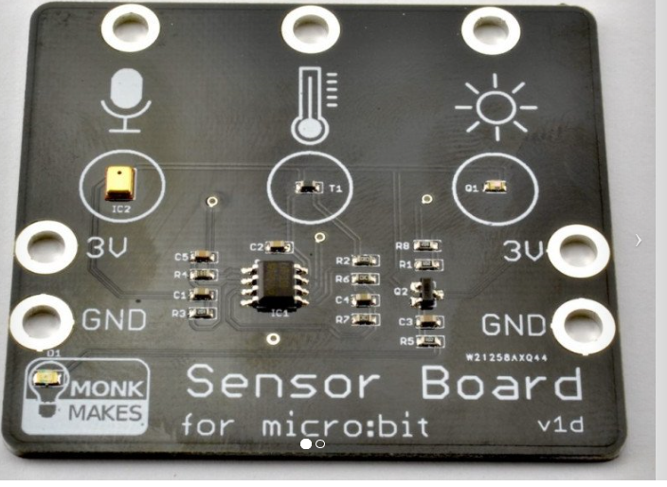
SENSOR-BOARD, MONK MAKE

For tilslutning, se næste side.

For kodning:

https://www.monkmakes.com/mb_sensor/

